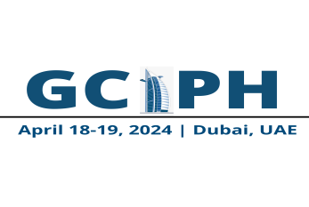
Example Abstract Format (250-300 words)

Main Author: *Erica Edfort, Chamberlain University, USA

Title: Stroke Education for APNs: How can they improve the care process?
Background: The 1st state-wide study investigating the perceptions of stroke care in New Jersey, identified lack of documentation of stroke pathway/orders as one of the reasons affecting outcomes of care (Edfort, 2010).
Objective: The need for guideline compliance for acute stroke care is an ongoing problem for all healthcare facilities. Edfort (2010) recommended implementing processes to address the deficiencies in stroke guideline compliance.
Method: In 2017, a second state-wide stroke study was conducted in New Jersey implementing Dr. Edfort’s recommendations for improving stroke core measure compliance (Singh, 2017).
Results: Attending a stroke specific education program, attendees reported increasing their knowledge of managing stroke patients as well as increasing their proficiency level in care processes.
Conclusion: Providing an education program focusing on the core measures provides an advantage to our patients as well as keeping the health care facility in compliance with stroke management protocols.
Keywords: stroke, patient care, APNs, education

Biography (50-100 words):
I have over 15 years’ experience as a stroke health care professional working with several hospitals systems developing the protocols to manage the care of the acute stroke patient. I have many years’ experience educating stroke patients, family members, the community and a variety of stoke health care professionals through the state of New Jersey to provide the highest level of care possible. As an educator, I now teach my students the processes to follow to provide appropriate levels of care for the acute stroke patient.

Please send your Biography along with below details
1. Full name: Paste your photo here

2. Title/Position:
3. Department:
4. Area of Speciality:
5. University/Organization:
6. Country:
7. Mobile/Whatsapp Contact:
8. Email Address:
9. Category: (Oral/Poster/Workshop/Pre-Recorded Video)
10. Name for the Certificate:

(Optional)

1. Facebook ID:
2. Twitter ID:
3. Linked ID:
4. Instagram ID:
5. Personal Website (if any):

